SUSAN BISHOP CRISPELL | MEDIA KIT | 2021

Biography
Susan Bishop Crispell earned a BFA in creative writing from the University of North Carolina at Wilmington. Born and raised in the mountains of Tennessee, she now lives twenty minutes from the beach in North Carolina with her husband and their literary-named cat. She is very fond of pie and is always on the lookout for hints of magic in the real world. She is the author of women’s fiction, including The Secret Ingredient of Wishes (Sep 2016) and Dreaming in Chocolate (Feb 2018), which was selected as a SIBA Okra pick Winter 2018, and her forthcoming young adult debut, The Kissing Season (May 2022).

Social Media Links
Website: http://www.susanbishopcrispell.com/
Blog: https://susanbishopcrispell.wordpress.com/
Twitter: https://twitter.com/SBCrispell
Facebook: https://www.facebook.com/AuthorSusanBishopCrispell
Pinterest: https://www.pinterest.com/sbcrispell/
Instagram: https://www.instagram.com/sbcrispell/
Goodreads: https://www.goodreads.com/author/show/7257289.Susan_Bishop_Crispell
Amazon: https://www.amazon.com/Susan-Bishop-Crispell/e/B00HX8MEDI/ref=dp_byline_cont_ebooks_1

Books
The Secret Ingredient of Wishes
Rachel Monroe, 26, can make wishes come true just by thinking about them. But it’s a gift that has caused more harm than good. And after her mother’s death, which Rachel blames herself for, she decides it’s time to leave her hometown—and her past—behind.

But when Rachel gets stranded in small-town Nowhere, NC—also known as the town of “Lost and Found”—she realizes she can’t escape her past, or her gift. In Nowhere Rachel is taken in by a spit-fire old woman, Catch, who binds the townspeople’s secrets by baking them into pies, and who has an uncanny ability to see exactly what Rachel is trying to hide. She also meets Ashe, Catch’s neighbor with southern charm and a complicated past, who makes her want to believe in happily-ever-after.

As she settles into the small town, she hopes her own secrets will stay hidden—especially the one about how she wished her little brother out of existence when they were kids. But starting over is harder than she thought, and when her wish-granting secret is revealed, the town people’s wishes begin popping out of thin air everywhere she goes. Scared the wishes will go wrong like in the past, she tries to ignore them, which only makes the wishes more determined to get her attention. Then when Rachel is forced to confront the truth about her brother, she must accept her magical ability or risk losing those she has come to love—and a chance at happiness—all over again.

Dreaming in Chocolate
A story of love, hot chocolate, and one little girl's wish for her mother that will make your heart melt.

With an endless supply of magical gifts and recipes from the hot chocolate café Penelope Dalton runs alongside her mother, she is able to give her daughter almost everything she wants. The one sticking point is Ella’s latest request: get a dad. And not just any dad. Ella has her sights set on Noah Gregory, her biological father who’s back in town for a few months – and as charming as ever.

Noah broke Penelope’s heart years ago, but now part of her wonders if she made the right decision to keep the truth of their daughter from him. The other, more practical part, is determined to protect Ella from the same heartbreak. Now Penelope must give in to her fate or face a future of regrets.

Representation/Rights Inquiries
Jenny Bent, The Bent Agency

Author Photo
Credit: Belinda Keller
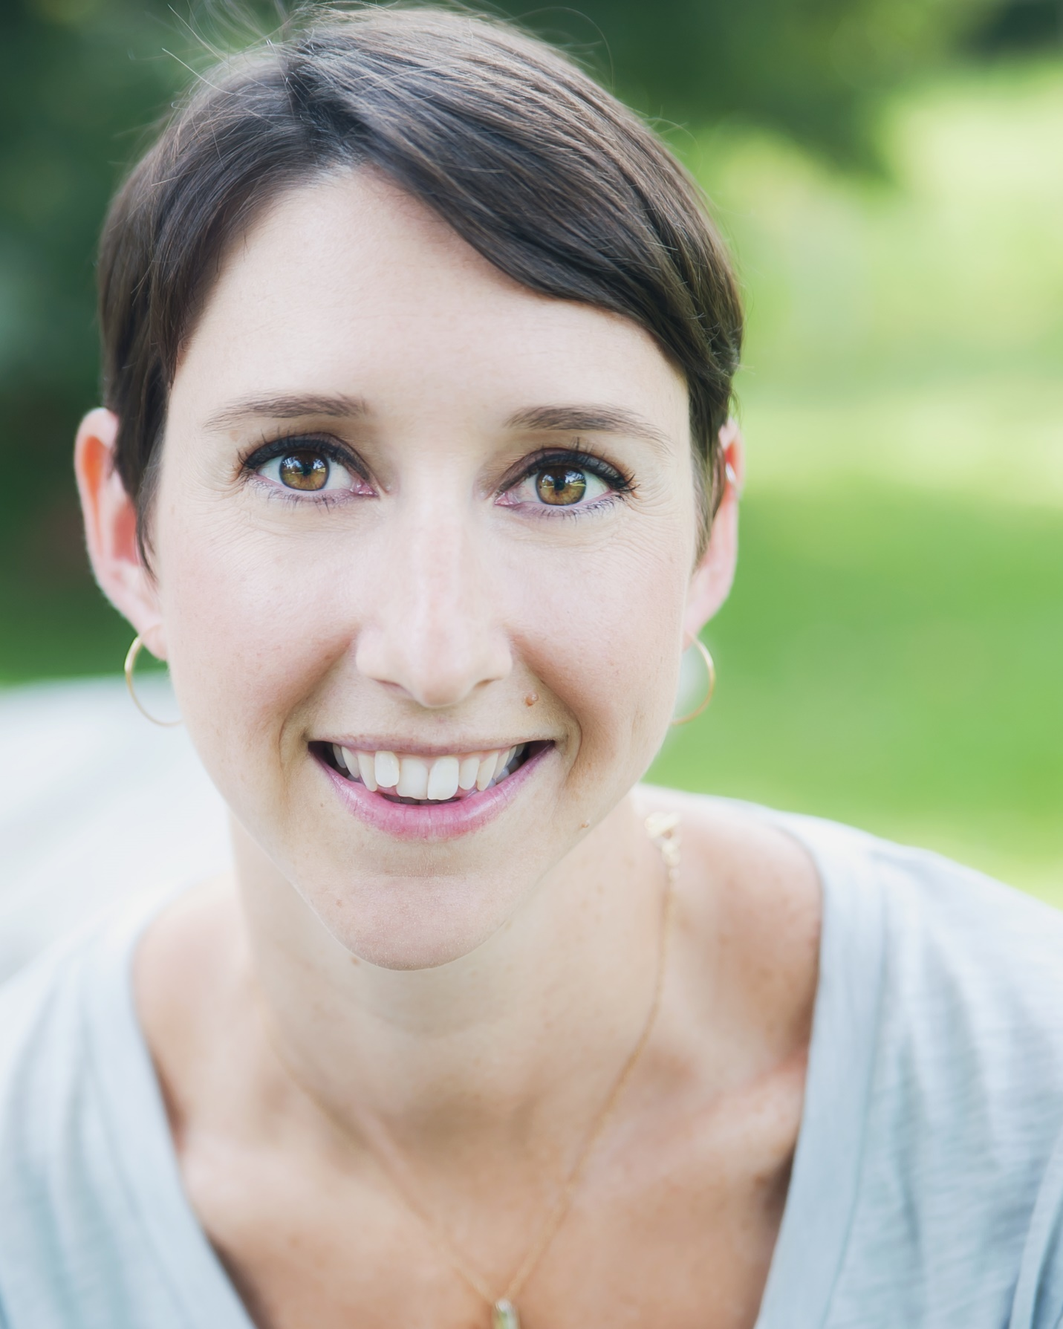

Book Covers
